

**Africa’s First Largest Agricultural Technology Exhibition & Conference**

Exhibitor Registration Details

## Conference Topics (content OF YOUR CONFERENCE)

**AGRITECH NIGERIA OSUN 2025.**

**DATE: 8-10 April,2025.OSOGBO,NIGERIA**

Other (Please specify)

Transport Storage Farm Inputs

Precision Agriculture & Digitization Systems & Components

Renewable Energy

Tractors

Soil Working & Seed-bed Preparation Drilling & Sowing

Plant Protection & Fertilizing Irrigation

Harvesting

**Product Index (What products and services do you offer?)**

Please fill the section below “X” (Multiple Choice)

Website:

E-mail:

CEO:

E-mail:

Mobile:

Position:

Contact Person:

Address & Code:

Company name:

Topic

Speakers/Company

Topic

Speakers/Company

**Seller Information (Help us to serve you better. What buyers would you like to meet at the exhibition?)**

|  |  |
| --- | --- |
| **Stand Type: Raw Space | Basic Booth | Premium Booth | Pavilion Booth,Conference** | |
| **Booth Location** | **Regular Rates**  Price / Sqm |
| **Raw Exhibition Area in Hall (min. 9m**2) | $78 |
| **Outdoor Exhibition Area (min,20m)** | $25 |
| **Standard Booth (min. 9 m**2)** | $150 |
| Conference Registration Fee | $120 |
| Sub-Total |  |
| * Raw Area consists of 1 Information counter, 2 Folding chairs, 2 Fluorescent lights, 1 Power socket, 1 Wastebasket  Standard booth package consists of 1 Information counter, 2 Folding chairs, 1 Round table, 2 Easy chairs, 2 Fluorescent lights, 1 Power socket, 1 Wastebasket, 1 Front facial digital print, 2 security,30 words on exhibition catalogue.. For special design wall paper,projector,roll-on banner,it attract $520 additional cost | |
| Corner Charge | 7% |
| Co-exhibitors | $400/ Company |
|  |  |
| Registration Fee | $50 / Company |
| VAT | 5% |

**Participation Costs Booth No:**

**Note:**

Industry/Segment/Company

Contact Person/E-mail

Industry/Segment/Company

Contact Person/E-mail

Industry/Segment/Company

Contact Person/E-mail

## Total:

*Kindly make your payment within 21 days after the invoice is issued in order to confirm your booking. Payment options:

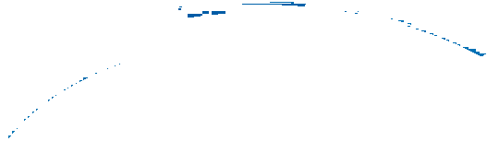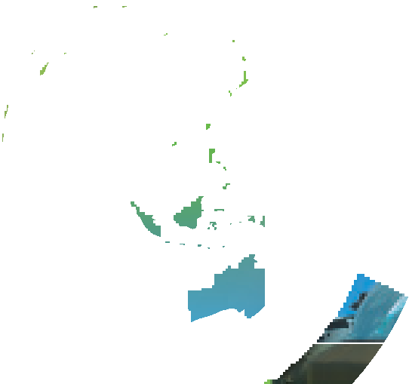

**Exhibitor Registration Form**

 By Wire Transfer

Account Name:FESCO AGALU ENTERPRISEsS NIGERIA LIMITED,

Bank Account-5854419023(Dollar acct), 5854419016(Naira acct))

Bank Name: First Monument Bank PLC, Osogbo Branch,Sort Code-214-190—036,FCMBNGLAWEB

 Online payment with credit card is allowed (2% Surcharge Apply)

Letter of invitation shall be issue to assist the participant for Visa process

**CONTRACT ATTESTATION**

This is to confirm that WE/I……………………………………………………………………………………… are participating in AGRITECH NIGERIA,OSUN 2025 as EXHIBITOR and fully agreed with term and Condition of the participation

Company Name………………………………………………………Date………………………………………..Payment Teller Number………………….

## 

Return this Application booking form to E-mail info@agritechnigeria.net

I hereby sign to accept this contract and to confirm the space reservation at Agritech Nigeria ,Osun 2025

Fesco Agalu Nigeria Limited reserved the right to alter, change, or cancel the space reservation if the aforementioned confirmation conditions have not been completed.

ALL YOUR DATA IS PROTECTED UNDER NIGERIA DATA PROTECTION ACT 2018

**Please download it and send to** [**info@agritechnigeria.net**](mailto:info@agritechnigeria.net) **or fescoagalu93@gmail.com**

**Call +2347077163490 ,+2348050427776,+2348158492027**